COVID-19 Safety Plan
Event application

Table of Contents
COVID-19 Safety Plan – EVENT APPLICATION 3
Event Details 3
Before you get started 3
Section 1– Overview of the Event 3
Section 2 – Reducing Contact Intensity & Contact Frequency 4
Section 3 – Health Screening & other Self-Isolation Requirements 4
Section 4 a – Physical Distancing 4
Section 4 b – Source Control 5
Section 5 – Hygiene & Cleaning 5
Section 6 – Communication, Awareness & Enforcement 5
APPROVAL SECTION 6
Appendices 7
APPENDIX A: COVID-19 Campus Rules 7
APPENDIX B: COVID-19 Guidance for Common Areas 9
APPENDIX C: Risk Considerations 11
APPENDIX D – EXAMPLE 12

COVID-19 Safety Plan – EVENT APPLICATION
All on-campus events require a COVID-19 Safety Plan. This plan requires the review of the event environment and activities to ensure effective controls are in place to prevent the transmission of COVID-19. Completed applications are to be submitted to ready.ok@ubc.ca for review and approval.

Event Details
EVENT NAME
EVENT DATE
SPONSOR (relevant Dean, Director/AVP)
EVENT LEAD
EVENT LOCATION (Building/Outdoor)
EVENT LOCATION – ROOM / AREA

Before you get started
All proposed events must answer ‘yes’ to the following questions prior to submission for approval.

# | Condition | Yes/No
1 | Is the event sponsored/supported by the relevant Administrative Head of Unit (i.e. Dean, AVP, Director)?
2 | Is this a one-time, episodic or infrequent (i.e. annual) occurrence?
3 | Will there be no more than 50 patrons in attendance, with additional staff and/or service providers commensurate with physical distancing requirements?
4 | Does the event fall into a category either permitted under the current phase under the Province’s Restart plan (e.g. recreation) or not otherwise specifically addressed by the province in any phase?
5 | Have you completed the risk assessment (APPENDIX A) and able to incorporate all important risk mitigations to ensure a low risk event?

Section 1– Overview of the Event
Scope and Rationale for Event

Section 2 – Reducing Contact Intensity & Contact Frequency
This Plan should articulate strategies to reduce contact intensity (type of contact – close/distant, and duration of contact – brief/prolonged) and contact frequency (number of people within a setting, frequency of ‘collisions’).

The following categories of controls can be used to reduce the risk, including:
- Physical distancing measures – measures to reduce the density of people
- Engineering controls – physical barriers (like Plexiglas or stanchions to delineate space) or increased ventilation
- Administrative controls – clear rules and guidelines
- Personal protective equipment – like the use of respiratory protection

The following sections work through development and implementation of control measures aimed at reducing the potential for COVID-19 transmission.

Contact Intensity (proposed COVID-19 Operations)
Describe the type of contact (close/distant) and duration of the contact (brief/prolonged) that are expected at the event
Contact Frequency (proposed COVID-19 Operations)
Describe the frequency of contacts that are expected at the event (# of people present in setting at same time)

Section 3 – Health Screening & other Self-Isolation Requirements
Health Screening & other Self-Isolation Requirements
Describe how event participants will be informed of Health Screening and other Self-Isolation requirements.

Section 4 a – Physical Distancing
Event participants must be provided an environment where they are able to maintain physical distancing at all times. If physical distancing is not possible, Section 4 b must be completed.
Physical Distancing: Occupancy limits
Identify any occupancy considerations relating to the size and layout of the space and the number of event participants.
Physical Distancing: Circulation Routes
Describe any circulation expectations within the event location that support physical distancing. (if helpful, append relevant UBC COVID-19 Circulation Floor Plans for buildings being occupied)

Section 4 b – Source Control
Where employees are not able to maintain physical distancing, source control must be implemented.
Work Requirement
Identify event activities/situations where physical distancing cannot be maintained.
Partitions or Physical Barriers
Describe any inclusion of physical barriers to be used at public-facing or point-of-service areas
Face Coverings
Where physical distancing cannot be maintained and partitions/physical barriers are not practicable, Face Coverings must be used. Face-coverings may include non-medical masks and / or face shields. Where face coverings are required, the worker must be provided with the equipment and with education relating to limitations, use and care.

Section 5 – Hygiene & Cleaning
Cleaning and Hygiene
Detail your cleaning and hygiene plan.

Section 6 – Communication, Awareness & Enforcement
Communication Strategy for Employees
Describe how event participants will be informed of steps being taken to reduce risk of exposure to COVID-19 and of behavioural expectations while participating in the event.
Signage
Detail the type of signage you will utilize and how it will be placed (e.g. floor decals denoting one-way walkways and doors).
Enforcement
Detail how the event will be monitored for compliance with expectations and how non-compliance will be addressed.

APPROVAL SECTION
To be completed by Campus Operations and Risk Management

Where less than 3 pre-control risk considerations are present (SEE APPENDIX C), approval will be given by the Director, Campus Operations and Risk Management. Where 3 or more pre-control risk considerations are present and important risk mitigations cannot be adhered to, the event application may be forwarded to Resumption Planning and Coordination Committee for additional consideration.

Risk Assessment (# of pre-control risk considerations)
Office of CORM to assess COVID 19 risk considerations to determine if it meets ‘high risk’ criteria.

Office of Campus Operations and Risk Management
Approved or
Forwarded to Resumption Planning and Coordination Committee (RPCC)

Appendices

APPENDIX A: COVID-19 Campus Rules
The health and safety of the UBC community is our first priority, and we continue to monitor COVID-19 and follow effective safety practices as understanding of the virus evolves.
To ensure persons in all workspaces and other UBC property remain safe as possible, it is required that all persons follow these COVID-19 Campus Rules as well as any other rules required of them by UBC. These rules may be supplemented by more detailed UBC rules or safety protocols governing specific locations or activities – for example in location or unit specific COVID-19 Safety Plans. If there is any conflict between these COVID-19 Campus Rules and more detailed UBC rules – the more detailed rules will govern. These COVID-19 Campus Rules may be amended from time to time.
These COVID-19 Campus Rules govern UBC’s campuses and all other locations under UBC’s control (“UBC Premises”) and apply to all activities that take place on UBC Premises and all persons on UBC Premises. For greater certainty, UBC Premises do not include land leased to third parties (for example private residences, third party commercial spaces).
These rules do not govern student residents while they are in student residences operated by Student Housing and Community Services in Vancouver and Student Housing and Hospitality Service in Kelowna. Separate rules will apply to these students while they are in residence. These rules do apply to student residents when they are elsewhere on UBC Premises. The student housing rules for the Kelowna campus are here https://okanagan.housing.ubc.ca/covid-19-residence-rules/, and for the Vancouver campus are here https://vancouver.housing.ubc.ca/residence-life/health-safety/covid-19/.

1. All students, faculty, staff, and others must assess themselves daily for COVID-19 symptoms prior to engaging in in-person UBC activities on UBC Premises. A list of COVID-19 symptoms can be found here http://www.bccdc.ca/health-info/diseases-conditions/covid-19/about-covid- 19/symptoms
2. Anyone who is ill or believes they have COVID-19 symptoms or exposure to SARS-CoV-2 must complete the BC self-assessment tool at https://bc.thrive.health/ or through the BC COVID-19 Support App for their iOS or Android device and follow the instructions provided.
If the self-assessment tool recommends that a person get tested for COVID-19 or self-isolate they must do so. If required to get COVID-19 testing they should not return to UBC Premises until they have received the test results and followed any self-isolating recommendations. At the commencement of self-isolation:
i. Faculty and staff of UBC must report their condition to their supervisor and manager. Their supervisor or manager will advise them of their options.
ii. Contractors, volunteers or others with business on UBC Premises should advise their UBC contact person of their status.
3. All faculty and staff on campus must complete the mandatory online training module ‘Preventing COVID-19 Infection in the Workplace’ to be able to work on UBC Premises.
4. Anyone with a positive COVID-19 diagnosis can only return to work, or resume in-person UBC activities on UBC Premises, after 10 days have passed since the start of symptoms and the fever is gone. Additional information: http://www.bccdc.ca/health-info/diseases-conditions/covid-19/self- isolation .
5. Anyone who has travelled internationally or had contact with a COVID-19 infected person may only return to UBC Premises after 14 days and 10 days respectively and may only resume in- person activities at UBC Premises when the fever is gone and they are feeling better.
6. Everyone is advised to maintain physical distance from others as much as possible.
7. Everyone must follow relevant signage and floor markings when moving around UBC Premises.
8. Supervisors will ensure that all faculty, staff and contractors are familiar with the site specific COVID-19 Safety Plans for their work areas – these will layout the plan for occupancy, traffic flow and hygiene at your worksite and within your building.
9. All persons must wear an appropriate mask (defined below) when inside buildings on UBC Premises unless:
i. you are the sole occupant of an enclosed room; ii. one of the exceptions outlined in Attachment “A” apply; or iii. an approved COVID-19 Safety Plan has been implemented that provides specific guidance regarding the use of masks.
An appropriate mask must have three layers of tightly woven fabric (cotton or linen), or be a commercially produced three layer disposable non-medical mask, and securely fit, without gaping, over the nose and mouth with ties or ear loops. For more information on appropriate masks please see https://srs.ubc.ca/covid-19/health-safety-covid-19/
For more information regarding COVID-19 rules please see https://srs.ubc.ca/covid-19/health-safety-covid-19/
Ensuring Compliance:
* Everyone on UBC Premises must comply with these COVID-19 Campus Rules and any other UBC rules.
* The Administrative Head of Unit or Supervisor for each unit has the responsibility to ensure that UBC rules and safety protocols are followed in their unit.
* Notices regarding applicable UBC rules and safety protocols will be posted at entrances to work places as well as communal areas (for example lunchrooms) for all workspaces.
* All faculty, staff and students are encouraged to bring concerns about the implementation of UBC rules or safety protocols or incidents of non-compliance to the attention of the Administrative Head of Unit or Supervisor.
* For support in investigating incidents of non-compliance or similar concerns by faculty and staff, Administrative Heads of Unit or their designates should contact their Human Resources Advisor or Faculty Relations Senior Manager.
* Failure to follow these COVID-19 Campus Rules or other rules or safety protocols by faculty or staff may result in discipline up to and including the termination of employment.
* Failure to follow these COVID-19 Campus Rules or other rules or safety protocols by students may result in discipline pursuant to the UBC Student Code of Conduct. For support regarding the application of the UBC Student Code of Conduct, Administrative Heads of Unit can contact Campus Security.
* Failure to follow these COVID-19 Campus Rules or other rules or safety protocols by contractors may result in the termination of your contract, and/or loss of access privileges up to and including being restricted from visiting UBC Premises.
* Failure to follow these COVID-19 Campus Rules or other rules or safety protocols by volunteers, visitors or other third parties on UBC Premises may result in loss of access privileges up to and including being restricted from visiting UBC Premises.
Attachment “A” to UBC COVID-19 Campus Rules
Indoor Mask Exceptions
General Exceptions
* Persons unable to wear a mask due to a health condition, including physical, behavioural, psychological or cognitive impairment;
* Persons unable to put on or remove a mask without the assistance of another person;
* Where communication with a person requires that a person to be able to see the speaker’s mouth;
* If the mask is removed temporarily for the purposes of identifying the person wearing it;
* Children five years of age or younger are not required to wear a mask, although children over the age of two years should do so if possible. Note that certain locations at UBC (for example those operated by UBC Childcare Services) may have more detailed rules with respect to children wearing masks;
* Persons consuming food or beverages while seated in UBC dining facilities in seating areas designated for consuming food or beverages in accordance with an approved COVID-19 Safety Plan;
* While receiving a service from a health professional, if removing the face covering is necessary in order to receive the service;
* UBC faculty or staff or other persons assisting with a health or safety emergency;
* While on residence property residents of residences operated by Student Housing and Community
Services in Vancouver and Student Housing and Hospitality Service in Kelowna are not subject to these Campus COVID-19 Rules but must comply with the housing specific rules for their residence area.
APPENDIX B: COVID-19 Guidance for Common Areas
All workers attending UBCO buildings are required to have an approved COVID-19 Safe Work Plan for their particular work activity and/or work area and to have completed the mandatory ‘Preventing COVID-19 Infection in the Workplace’ online training.
This Common Area Safety Plan and the associated Building Circulation Plan is a required attachment to COVID-19 Safe Work Plans and must be part of the training and education that supervisors perform with their employees.
OUTDOOR AREA: GENERAL EXPECTATIONS
All campus occupants are required to maintain physical distance (separation of 2m) while occupying or circulating through outdoor areas of the campus.
In general, those circulating around campus should stay to the right of the surface that they are travelling on and yield to oncoming pedestrians.
INDOOR AREAS: General Expectations
Campus occupants are expected to respect physical distancing guidelines (maintaining 2m separation) while circulating around campus.
IN CASE OF EMERGENCY: Follow the building fire evacuation directions out of the building. In evacuation situations it is permissible to disregard COVID-19 building circulation directions as all building occupants will be leaving the building. It is recommended to follow physical distancing guidelines, in evacuation situations.
Interior Signage
All buildings will have the following signs at entrances:
- Building Circulation Floor Plan
- COVID-19 Rules
Interior building signage will be installed as identified by the Circulation Floor Plans.
Note: Individual Work units will apply signage in their work areas per their COVID-19 Safe Work Plans.
Building Circulation & Occupancy Floor Plans
The Building Circulation Floor Plans provide instructions to occupants in relation to circulation through, and use of, general building areas. These Floor Plans identify the following areas:
- Building Access / Egress
- Common Hallways
- Washrooms
- Kitchens/Lounges
- Stairwells
- Elevators

Building Access & Egress
Many doors on campus have been identified specifically as ‘entrance’ or ‘exit’ in order to minimize the number of contacts in these areas. In general, main building entrances are now being used exclusively as entrances, where other doorways are exits. See the Building Circulation Floor Plans for details for each campus building.
Public Walking Areas / Hallways
Adhere to Building Circulation Floorplans, Directional Signs, and Floor Decals. In all areas, occupants are asked to Walk on the Right Side of the corridor/hallway/sidewalk. If 2m separation cannot be maintained, yield to oncoming pedestrians and move to the side to allow adequate physical distancing.
Furniture in these areas have either been removed or taken out of use in order to support physical distancing measures. Building occupants are asked to not relocate common building furniture.
Washrooms
Washrooms are identified on the Building Circulation Floorplans and have signage at the entrance indicating the maximum number of occupants. Sinks and Urinals have been removed from service to ensure 2m separation between users. Doors have been removed, where appropriate, to reduce the number of common contact surfaces. Washroom users should appropriately wash their hands when entering and exiting the washroom facility.
When entering a washroom that is in use by the listed maximum occupancy, you are asked to leave the washroom and wait in the hallway, ensuring a 2-meter distance is maintained.
Stairwells
Adhere to Building Circulation Floorplans and Directional Signs. Many stairwells on campus have been identified specifically as ‘up’ or ‘down’ in order to minimize the number of contacts in these areas. There are many campus stairwells however, that continue to be open in both directions and occupants are asked to climb the stairs on the Right Side and yield to oncoming pedestrians.
Elevators
Physical distancing must be maintained when using campus elevators. In most situations this means only one person can use the elevator. Each elevator on campus has a sign indicating expectations for use.
In order to reduce the number of common touch points and wait time for those that need to use elevators, elevators should only be used by those who are unable to use building stairwells.
Kitchen / Lounge Areas
UBC has established and posted behavioural expectations and occupancy limits for these areas. Look for a sign adjacent to the entrance that indicates the maximum occupancy for the space and expectations for use of any equipment or supplies within the space.
It is recommended that campus users bring their own utensils and plates/cups to reduced shared use of common supplies. Cleaning supplies will be provided for users to perform supplementary cleaning of these area upon occupancy and prior to departure.
Additional infection control guidance can be located at: https://hse.ok.ubc.ca/covid19infectioncontrol/

APPENDIX C: Risk Considerations

Present | Risk Consideration | Context | Important Risk Mitigation
 | Risk #1 - Higher proportion of individuals from outside of the UBC community visit the campus/unit; if employees or staff are exposed to more than 10 random people in a day; or if the unit is public facing | The risk of COVID-19 introduction and spread is presumed to be greater as the number of contacts increases | - Physical Distancing  - Plexiglass barriers  - Reduction of high touch points / increased cleaning  - Cohort groups, where appropriate  - Hand hygiene  - Health Screening
 | Risk #2 - Prolonged close interaction with others not in the usual cohort of colleagues; if contact lasts for more than 15 minutes and transient in nature^{[1]} | Person-to-person spread is more likely with prolonged contact | - Physical Distancing  - Reduction of high touch points / increased cleaning  - Hand hygiene  - Health Screening
 | Risk #3 - The workplace or activity is indoors and windows cannot be opened | A confined indoor space is presumed to have greater risk | - Physical Distancing  - Reduction of high touch points / increased cleaning  - Hand hygiene  - Health Screening
 | Risk #4 - Employees/students/visitors have frequent contact with high-touch surfaces | A higher frequency of contact with high-touch surfaces (e.g., service counters, card payment machines) is presumed to have greater risk | - Enable two metre physical distancing  - Use of plexiglass barriers wherever possible  - Reduction of high touch points or increased cleaning  - Enable and encourage increased hand hygiene  - Strict non-admittance to anyone with symptoms
 | Risk #5 - The activity involves people who are at higher risk of severe illness (i.e., older adults or those with chronic health conditions) | COVID-19 can cause more severe illness among people who are 65 and over, and those who have compromised immune systems or other underlying medical conditions | - Work with HR for individual accommodations  - Encourage work from home arrangements  - Physical distancing  - Reduction of high touch points / increased cleaning  - Hand hygiene  - Health Screening
 | Risk #6 - The activity involves people who are not able or likely to follow hygiene practices, respiratory etiquette, and health screening (e.g., childcare facilities, day camps) | COVID-19 spread can occur when personal preventive practices are not consistently followed. For example, young children are less likely to be able to carry out these practices | - Reduction of high touch points / increased cleaning  - Limiting of non-essential contacts in space  - Health Screening

APPENDIX D – EXAMPLE
To be replaced with relevant floorplan

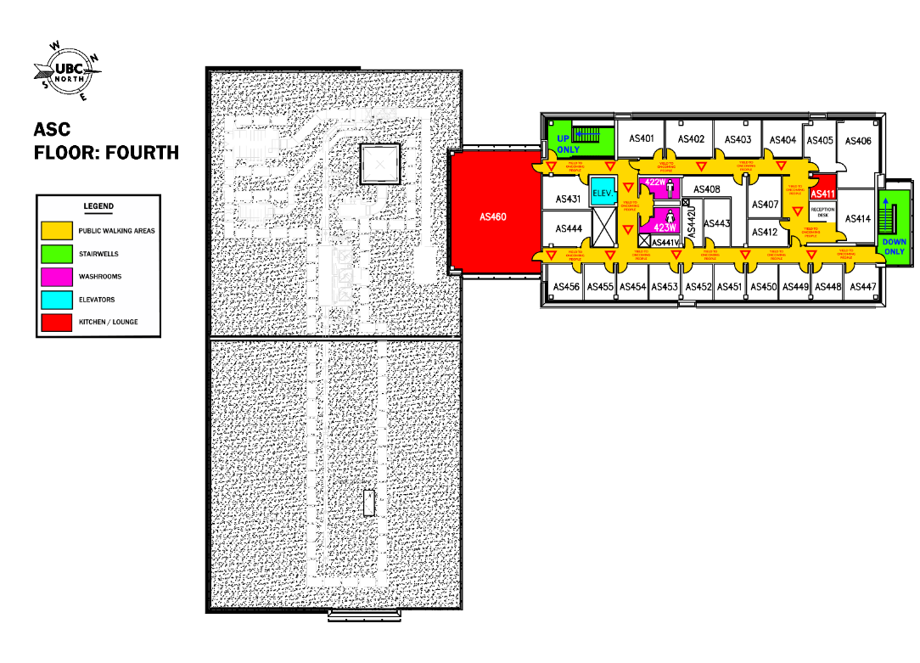

[1] PHAC. Updated Public Health Management of Cases and Contacts Associated with Coronavirus Disease 2019. (10 Apr 2020). [Available at : https://www.canada.ca/en/public-health/services/diseases/2019-novel-coronavirus-infection/health-professionals/interim-guidance-cases-contacts.html]

